GO_HEADER type ref to private IF_PURCHASE_ORDER_MM

gs_header_new type private MEPOHEADER

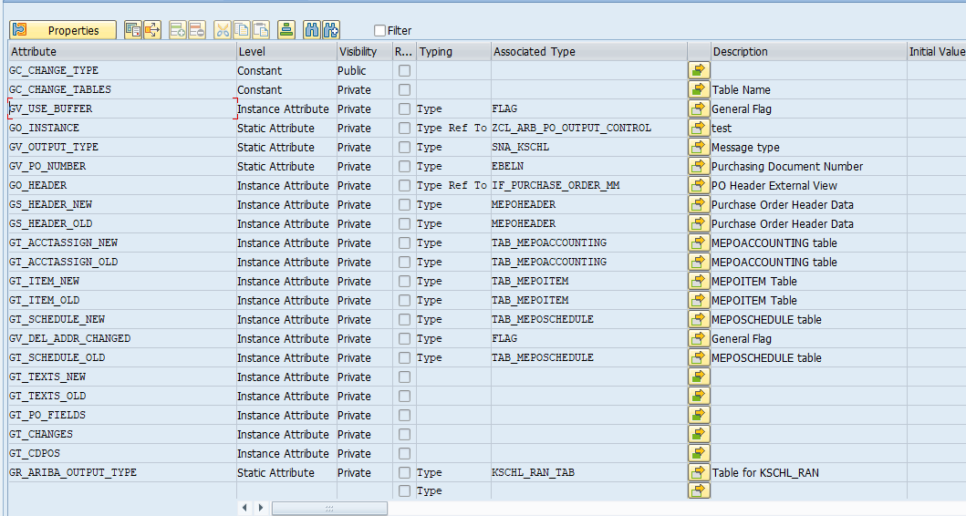

  method GET_DATA_FROM_BUFFER.  
     DATA:lo_item TYPE REF TO cl_po_item_handle_mm.  
  
    CHECK go_header IS BOUND.  
  
*   Get header data - New  
    gs_header_new = go_header->get_data( ).  
*   Get header data - old  
    IF go_header->is_persistent( ) = abap_true. " Does PO exists already?  
*     Begin of modification against RT_45848 - RV877752  
*     Get old data  
      go_header->get_persistent_data( IMPORTING  ex_data = gs_header_old  
                                      EXCEPTIONS no_data = 1  
                                                 OTHERS  = 2 ) .  
      IF sy-subrc <> 0.  
        CLEAR gs_header_old.  
      ENDIF.  
*     End of modification against RT_45848 - RV877752  
    ENDIF.  
  
*   Get Header Texts - New  
*   Get all header text types  
    CALL METHOD go_header->if_longtexts_mm~get_types( IMPORTING ex_texttypes = DATA(nt_texttypes) ).  
    LOOP AT nt_texttypes ASSIGNING FIELD-SYMBOL(<nfs_texttypes>).  
*     Fill in all header texts - New  
      CALL METHOD go_header->if_longtexts_mm~get_text  
        EXPORTING  
          im_tdid      = <nfs_texttypes>-tdid  
          im_texttype  = <nfs_texttypes>  
        IMPORTING  
          ex_textlines = DATA(nt_lines).  
*     Collect al texts into one table.  
      APPEND INITIAL LINE TO gt_texts_new ASSIGNING FIELD-SYMBOL(<nfs_texts_new>).  
      <nfs_texts_new>-tdid = <nfs_texttypes>-tdid.  
      <nfs_texts_new>-lines = nt_lines.  
      CLEAR nt_lines.  
    ENDLOOP.  
  
  
*   Get PO items  
    DATA(nt_items) = go_header->get_items( ).  
    LOOP AT nt_items ASSIGNING FIELD-SYMBOL(<nfs_items>).  
*     Get Item data - new  
      DATA(ns_item) = <nfs_items>-item->get_data( ).  
      APPEND ns_item TO gt_item_new.  
      CLEAR ns_item.  
  
*     Get Item data - Old  
      IF  <nfs_items>-item->is_persistent( ) = abap_true. " Does PO Item exists already?.  
*       Begin of modification against RT_45848 - RV877752  
*       Get old data  
        <nfs_items>-item->get_persistent_data( IMPORTING ex_data = ns_item  
                                               EXCEPTIONS no_data = 1  
                                                          OTHERS  = 2 ).  
        IF sy-subrc = 0.  
          APPEND ns_item TO gt_item_old.  
        ENDIF.  
*       End of modification against RT_45848 - RV877752  
        CLEAR ns_item.  
      ENDIF.  
  
*     Check if the item delivery address is changed or not.  
      lo_item ?= <nfs_items>-item.  
      DATA(ns_cmmda) = lo_item->if_delivery_address_mm~get_address_detail( ).  
      IF ns_cmmda-changed_da = abap_true.  
*       If changed, then update buffer vaiable.  
        gv_del_addr_changed = abap_true.  
      ENDIF.  
  
*     Get Schedule line data of item  
      DATA(nt_schedules) = <nfs_items>-item->get_schedules( ).  
      LOOP AT nt_schedules ASSIGNING FIELD-SYMBOL(<nfs_schedules>).  
*       Get Schedule line data of item - New  
        DATA(ns_schedule) =  <nfs_schedules>-schedule->get_data( ).  
        APPEND ns_schedule TO gt_schedule_new.  
        CLEAR ns_schedule.  
  
*       Get Schedule line data of item - Old  
        IF  <nfs_schedules>-schedule->is_persistent( ) = abap_true. " Does PO Item schedule line exists already?.  
*         Begin of modification against RT_45848 - RV877752  
*         Get old data  
          <nfs_schedules>-schedule->get_persistent_data( IMPORTING ex_data = ns_schedule  
                                                          EXCEPTIONS no_data = 1  
                                                                     OTHERS  = 2 ).  
          IF sy-subrc = 0.  
            APPEND ns_schedule TO gt_schedule_old.  
          ENDIF.  
*         End of modification against RT_45848 - RV877752  
          CLEAR ns_schedule.  
        ENDIF.  
      ENDLOOP.  
  
*     Get account assignment data of item  
      DATA(nt_acctassign) = <nfs_items>-item->get_accountings( ).  
      LOOP AT nt_acctassign ASSIGNING FIELD-SYMBOL(<nfs_acctassign>).  
*       Get account assignment data of item - New  
        DATA(ns_acctassign) =  <nfs_acctassign>-accounting->get_data( ).  
        APPEND ns_acctassign TO gt_acctassign_new.  
        CLEAR ns_acctassign.  
  
*       Get account assignment data of item - Old  
        IF  <nfs_acctassign>-accounting->is_persistent( ) = abap_true. " Does PO Item schedule line exists already?.  
*         Begin of modification against RT_45848 - RV877752  
*         Get old data  
          <nfs_acctassign>-accounting->get_persistent_data( IMPORTING  ex_data = ns_acctassign  
                                                            EXCEPTIONS no_data = 1  
                                                                       OTHERS  = 2 ).  
          IF sy-subrc = 0.  
            APPEND ns_acctassign TO gt_acctassign_old.  
          ENDIF.  
*         End of modification against RT_45848 - RV877752  
          CLEAR ns_acctassign.  
        ENDIF.  
      ENDLOOP.  
    ENDLOOP.  
  
  endmethod.